**Product Scope**

***MOD/ARI/ARH range***

|  |  |  |  |  |
| --- | --- | --- | --- | --- |
| **Approvals** |  | *By* | *Department* | *Date* |
| Compiled | *P. Antonello* | R&D | 16-Nov-22 |
| Verified | *L. Di Maio* | R&D |
| Approved | *M. Chiaravalli* | R&D |
|  | | | | |
| **References** | Project | SP00337- MOD and autoreclosing | | |
| Product | MOD, ARI and ARH | | |
| Documents |  | | |

TABLE OF CONTENTS

1 Introduction 4

2 Product type and offering 4

3 Installation 4

3.1 Compatibility [2.1.1.2] 4

3.2 Terminals 5

3.3 MOD and ARI Connection 6

3.4 ARH Connection (ARH) 6

3.5 Accessories 7

4 Mechanical Requirements 8

4.1 Max Dimensions 8

4.2 Number of operations 10

4.3 Material 10

4.4 Misuse 10

5 Electrical Requirements 10

6 Environmental conditions 11

7 Operations 11

7.1 MOD 11

7.1.1 MOD operations during a mains voltage drop (black-out) 12

7.2 ARI 13

7.2.1 ARI status 13

7.2.2 ARI operations during a mains voltage drop (black-out) 14

7.3 ARH 15

7.3.1 ARH operations during a mains voltage drop (black-out) 16

7.4 LED operations [2.1.8.1] 17

8 Connectivity 18

8.1 Wired Communication Accessory 18

8.2 Wireless Communication Accessory 18

8.3 Cloud connectivity and user interface 19

8.4 Configuration of wireless communication accessory. 19

8.5 FW Upgrade 20

9 Product and system standard 22

10 Packaging and labelling 22

10.1 Package 22

10.2 Label (on the package) 22

10.3 Marking (on the product) 22

10.4 Instructions leaflet 22

11 Marks and approvals 23

12 Documentation 23

13 Revision History 23

# Introduction

This document describes the technical requirements for the new product family of the motor drives and self-reclosing device for System Pro M MCB/RCDs product family. The requirements here described are answering to the Market requirements listed in the PTC integrity document ID 26940. Reference to the MRS requirement can be identified inside the squared brackets close to the requirement specification e.g. see [2.1.1.1.]

# Product type and offering

The following range of products aims to substitute the current ranges of Motor Operating Devices (MOD) and Automatic Reclosing Devices (ARD).

|  |  |  |  |
| --- | --- | --- | --- |
| **#** | **SKU** | **Product name** | **Description** |
| 1 | 2CSS202998R0033 | MOD | Motor Operating Device |
| 2 | 2CSS201998R0033 | MOD LV | Motor Operating Device “Low Voltage” |
| 3 | 2CSF202998R0034 | ARI | Automatic Reclosing Device for RCCBs without Id assessment |
| 4 | 2CSF201998R0034 | ARI LV | Automatic Reclosing Device “Low Voltage” for RCCBs without Id assessment |
| 5 | 2CSF203998R0034 | ARI-30 | Automatic Reclosing Device for RCCBs with 30s delay among attempts without Id assessment |
| 6 | 2CSF201998R0035 | ARH 2P 30mA | Automatic Reclosing Device for 2P RCCBs with Id assessment for 30mA Idn |
| 7 | 2CSF202998R0035 | ARH 2P 300mA | Automatic Reclosing Device for 2P RCCBs with Id assessment for 300mA Idn |
| 8 | 2CSF203998R0035 | ARH 4P 30mA | Automatic Reclosing Device for 4P RCCBs with Id assessment for 30mA Idn |
| 9 | 2CSF204998R0035 | ARH 4P 300mA | Automatic Reclosing Device for 4P RCCBs with Id assessment for 300mA Idn |
| 10 | 2CSS201998R0036 | COMM1_RS485 | Communication Module (accessory) with Modbus RTU on RS485 |
| 11 | 2CSS202998R0036 | COMM2_WiFi | Communication Module (accessory) with Wi-Fi |
| 12 | 2CSS201998R0038 | MOD (Hager) | Motor Operating device for Hager brandlabel |

The classification of the standard IEC63024 for ARD, recognize two groups of ARD:

* 4.3.1 ARD without assessment means à ARI
* 4.3.2.1 ARD with means of assessment of the prospective residual current à ARH

# Installation

The products shall be able to be mounted on horizontal or vertical DIN rail (acc. to EN 60715 35 mm) by fast clip. Each product will have its own fast clip since the mounting cannot be granted only through the hooks between the products and the Main Protection Device (MPD) [2.1.1]

## Compatibility [2.1.1.2]

|  |  |  |  |  |  |
| --- | --- | --- | --- | --- | --- |
| **compatibility with…** | **MOD** | **ARI ARI-30** | **ARH 2P** | **ARH 4P** | **Notes** |
| S200 (1P to 4P) | Yes | - | - | - |  |
| SD200 (1P to 4P) | Yes | - | - | - |  |
| F202 30mA | Yes | Yes | Yes | - |  |
| F202 300mA | Yes | Yes | Yes | - |  |
| F204 30mA | Yes | Yes | - | Yes |  |
| F204 300mA | Yes | Yes | - | Yes |  |
| F200 2P and 4P  (other sensitivities) | Yes | Yes | - | - |  |
| DS201 | Yes | - | - | - |  |
| DS202C | Yes (Aim) | - | - | - | ***DEVIATION*** - Interference between the test pushbutton and the MOD handle. It will be verified on the first prototype |
| DS203NC | - | - | - | - | ***DEVIATION*** |
| Slim range:   * SN201 "new" * UNIBIS "new" * RCBO VI 1M “new” | Not in scope for this project | - | - | - | ***DEVIATION*** - It will be considered if future version of "UNIBIS MCB" and "SN201 MCB" will be aligned to the S200 main working points (toggle rotation of 75°, accessories interface position, accessories coupling points). Any deviation from these constraints implies the design of a dedicated MOD. |

The product shall be capable of being installed in ABB consumer units with max depth of modules less than 74 mm for MOD and ARI, 76 mm for ARH [2.1.2].

Complete compatibility table up to PL3 product level is attached here.



## Terminals

The terminals for MOD and ARI will be plug-in type, with 5 mm pitch, and capable to get cables with 0,2…2,5 mm2 cross section [2.1.3].

The tightening torque will be 0,4 Nm and the wire stripping length will be 5 mm [2.2.4.1 and 2.2.4.2]

|  |  |
| --- | --- |
| **Pitch** | 5 mm |
| **Poles** | 6 |
| **Screw head** | Phillips-Slot recess (H1L) |
| **Thread** | M2,6 |
| **Rated current** | 12 A |
| **Rated voltage** | 400 V |
| **Tensione di dimensionamento (III/3)** | 250 V |
| **Tensione impulsiva di dimensionamento (III/3)** | 4 kV |
| **Collegamento** | Screw connection with cage |
| **Rigid cable cross section** | 0,2 mm² ... 2,5 mm² |
| **Flexible cable cross section** | 0,2 mm² ... 2,5 mm² |
| **Strippng lenght** | 5 mm |
| **Tightening torque** | 0,35 Nm ... 0,4 Nm |
| **Housing insulation material** | PA |
| **UL 94 flammability class** | V0 |

## MOD and ARI Connection

The connection for MOD and ARI shall be the following:

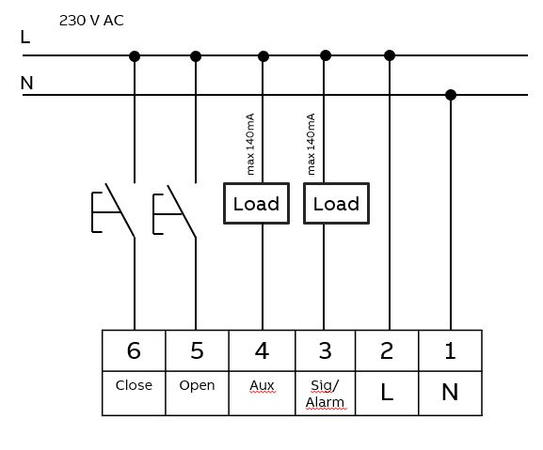

The AUX and SIG/ALARM output operates according the table for all SKUs (expect MOD HAGER 2CSS201998R0038)

|  |  |
| --- | --- |
| **MPD status** | **AUX status** |
| Closed contact | voltage of neutral line (AC) or 0 V (DC) |
| Open contact | Floating |

|  |  |
| --- | --- |
| **MPD status** | **SIG Status** |
| MPD trip | voltage of neutral line (AC) or 0 V (DC) |
| MPD no trip | Floating |

The AUX and SIG/ALARM output of MOD Hager operate according the table

|  |  |
| --- | --- |
| **MPD status** | **AUX status** |
| Closed contact | Floating |
| Open contact | voltage of neutral line (AC) or 0 V (DC) |

|  |  |
| --- | --- |
| **MPD status** | **SIG Status** |
| MPD trip | Floating |
| MPD no trip | voltage of neutral line (AC) or 0 V (DC) |

The ratings of those connections are the following:

|  |  |  |
| --- | --- | --- |
|  | **MOD/ARI/ARI-30** | **MOD/ARI LV** |
| Input Voltage range  (Close/Open) | 95…265 VAC | 20…53 VAC/DC |
| Output Voltage range  (AUX/SIGN/ALARM) | 95…265 VAC | 20…53 VAC/DC |
| Output Current range  (AUX/SIGN/ALARM) | 150 mA DC/RMS | 150 mA DC/RMS |

The cable length of the control circuits shall be maximum 10 m. [2.1.4.2]. ***DEVIATION***

## ARH Connection (ARH)

ARH will have a 3P plug-in terminal on top side for the Power Supply and the Alarm contact.

ARH will have 2 (2P) or 4 (4P) external cables on bottom side to perform the Id assessment. These cables will have 0,2 mm2 cross section (AWG 24) and enough length to reach the opposite side of the associated RCCB terminals (see picture); this length has been defined equal to 100 mm as on current ARH [2.1.4.1]. These cables will end with a crimped terminal.

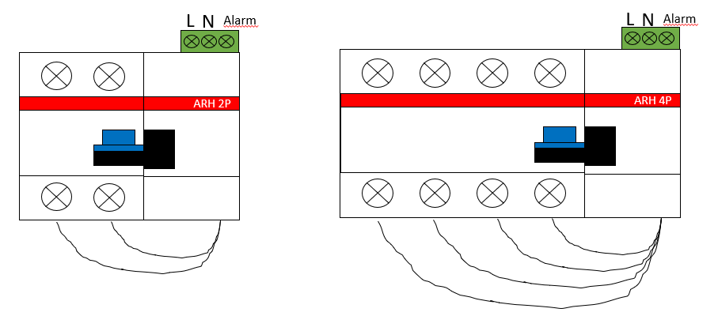

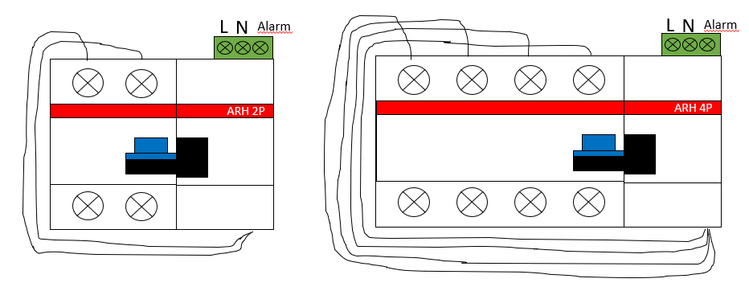

## Accessories

The MOD/ARI/ARH range will have the possibility to manage the following existing accessory for S2/F2 range, to be assembled on the right of the reclosing device [2.3.1]:

* Auxiliary contacts S2C-H6R
* Auxiliary contacts S2C-H6xxR
* Signal contacts S2C-S/H6R
* Shunt-trips F2C-A
* Undervoltage release S2C-UA
* Overvoltage release S2C-OVP

**Agreed change request**. In case of MOD device coupled with DS201 RCBO the following accessories are not mandatory in the first product release: Shunt-trips F2C-A, Undervoltage release S2C-UA, Overvoltage release S2C-OVP.

Shunt trip S2C-A cannot be assembled on the right side of the MOD/ARI cause to the different coupling points.

The maximum number of accessories mountable is 2 for the MOD/ARI while only 1 for ARH [2.3.3];

The communication modules shall be included in this total, since they have mechanical features inside for transmitting movements to accessories.

Order of mounting of accessories is described by the following diagram.

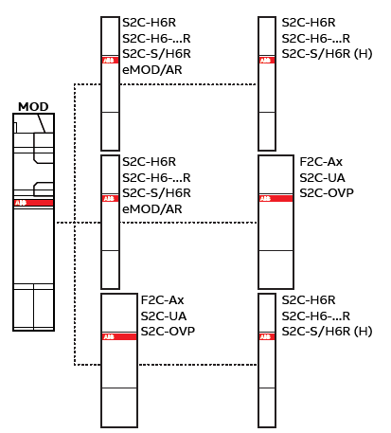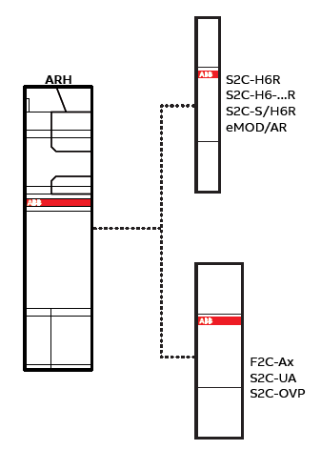

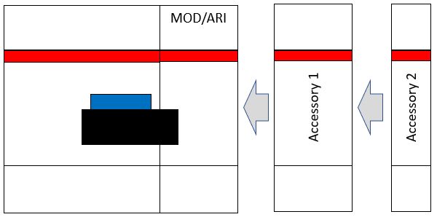 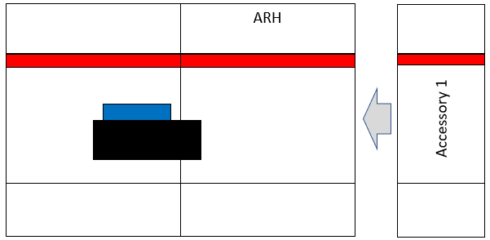

All the products in the range will have also the possibility to block the handle in OFF position, using a padlock with max diameter of **4mm** [2.3.2.1].

# Mechanical Requirements

## Max Dimensions

The dimension of the products shall not exceed the following overall dimensions [2.2.1.1]:

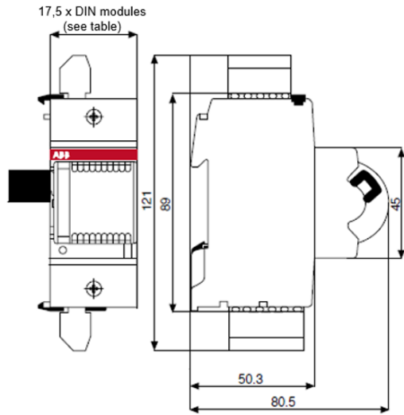

|  |  |
| --- | --- |
| Product | DIN Modules (17,5 mm each) |
| MOD | 1 |
| ARI/ARI-30 | 1 |
| ARH 2P | 1,5 |
| ARH 4P | 1,5 |
| COMM1_RS485 | 0,5 |
| COMM2_WiFi | 0,5 |

*MOD/ARI*

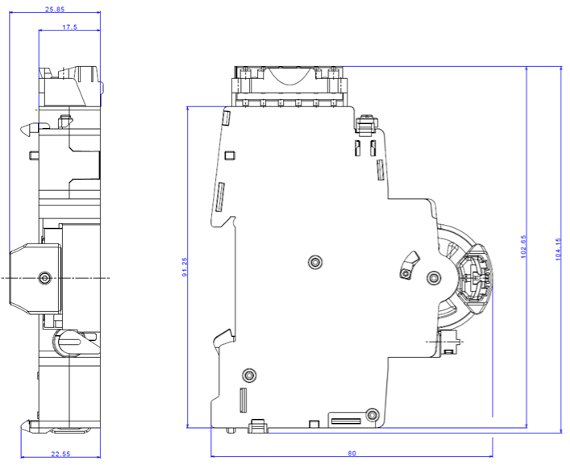

*ARH*

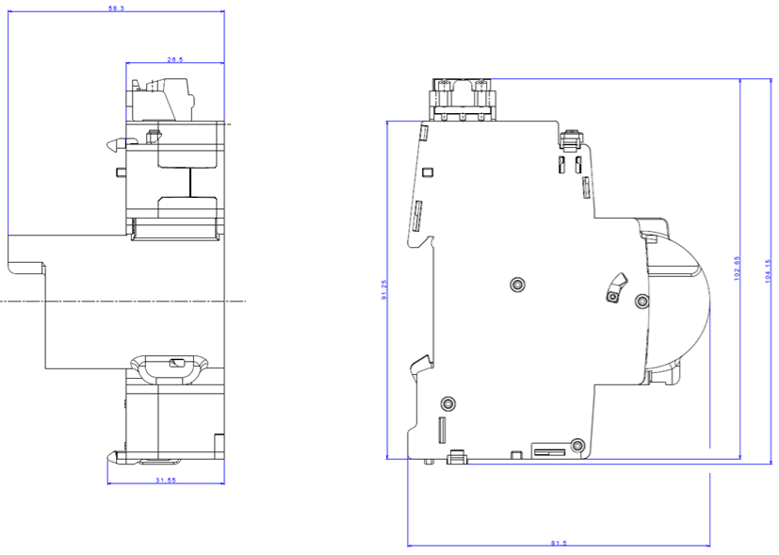

To evaluate possible alternatives to reduce the total height of the products

1. Change wire exit direction
2. Reduce wire cross section

MOD and ARI shall always have a plug-in connector.

## Number of operations

|  |  |  |
| --- | --- | --- |
|  | Minimum requested from the Standard | Internal Target |
| MOD | NA | 20.000 |
| ARI | 500 | 20.000 |
| ARH | 500 |  |

*As requested on [2.2.4.3]*

The operations are intended under the nominal load applied to MOD harm and without accessories:

* MOD: S204
* ARI/ARH: F204.

***DEVIATION***: Only for S204 100 A, the internal target is 10.000 operation instead of 20.000.

***DEVIATION***: Only for SKUs 2CSS201998R0038 (MOD Hager), the internal target is 10.000 operation instead of 20.000 (for every coupled device and/or accessories.

***Change request***: Compatibility ensured also with S204P (metal toggle) up to 10.000 operation

## Material

R26 (requirements for small electronic products) HL3 (highest hazard level) classification according to EN 45545-1:2013 and EN 45545-2:2013 [2.2.5.1.1]

V0 classification according to UL94 [2.2.5.1.2]

## Misuse

The operations from remote (Close/Open) shall be avoided through a locking mechanism, when the associated breaker is in off position [2.1.6.1]. In this locked condition, also the Automatic-reclosing operation are avoided (on ARI and ARH), in order to be safe during the maintenance services [2.1.6.2].

On ARH range, the handle must be covered completely when the Automatic-reclosing functionality is active [2.1.6.3].

# Electrical Requirements

|  |  |  |  |  |  |  |  |
| --- | --- | --- | --- | --- | --- | --- | --- |
|  | **MOD/ARI/ ARI-30** | **MOD LV** | | **ARI LV** | | **ARH 2P** | **ARH 4P** |
| Operating voltage | 110-240 VAC  *Range:*  ~~95~~ 100…265 VAC | 24…48 VAC/DC (+10…-~~15~~ 10%)  ***DEVIATION*** | | 24…48 VAC/DC (+10…-15%)  ***DEVIATION*** | | 230-240 VAC (+10…-15%) | 230-240 VAC (+10…-15%) |
| Operating Power consumption | < ~~20~~ 25VA | < 20VA | | < 20VA | | < 20VA | < 20VA |
| Idle state Power Consumption | < ~~0.4~~ 1.5VA | < ~~0.4~~ 1VA | | < ~~0.4~~ 1VA | | < 0,4VA | < 0,4VA |
| Rated Frequency | 50-60 Hz | | | | | | |
| Rated impulsive withstand voltage (1.2/50) Uimp | 4 kV | | 800 V | | 4 kV | | |
| Dielectric test voltage at ind. Freq. For 1 min | 2,5 kV   * *2 kV is the value requested from the standard* | | | | | | |
| Altitude | 2.000 m | | | | | | |
| “Make time” at ambient temperature | < 1 s | | | | | | |
| “Opening time” at ambient temperature | < 1 s | | | | | | |

[2.2.3]

Make time is defined as the time from the close signal to the breaker contact closing instant. Opening time is defined as the time from open signal to breaker contact opening instant.

# Environmental conditions

|  |  |
| --- | --- |
|  | **All products in range** |
| Protection degree frontal | IP40 |
| Protection degree terminals | IP20 |
| Ambient temperature (with daily average ≤ +35 °C) | -25 …+60 °C  *+60°C shall be considered with rated current of the MPD* |
| Storage temperature | -40 … +70 °C |
| Overvoltage category | III |
| Pollution degree, acc.to EN 60664 | ***DEVIATION*** - Level 2 |
| Damp heat test acc. to IEC/EN 60068-2-30 (°C/RH) | 28 cycles with 55°C/90-96% and 25°C/95-100% |
| Shock resistance acc. to IEC/EN 60068-2-27 | 25g, 2shocks, ~~16ms~~ 13ms ***[DEVIATION]*** |
| Vibration resistance acc. to IEC/EN 60068-2-6 | 1g - 20 cycle at 5… 150 …5 Hz |

# Operations

The on-site manual opening and closing of the coupled device shall be possible for all the products in range; for ARH it shall be possible only when the Automatic-reclosing is deactivated [2.2.2.1].

The remote opening and closing of the coupled device shall be possible (only for MOD and ARI) [2.2.2.2]

The Reset of the lock-out state (ARI) shall be possible only acting on the product [***DEVIATION*** from 2.2.2.11]. In case of opening remote command, the device will NOT go in lock-out state ***[DEVIATION]***.

There shall be foreseen a manual reset (on site) from lock-out state [2.2.2.10] for example moving the activation command to OFF and then to ON again, ~~or to activate manually the MPD~~***[DEVIATION]***..

## MOD

When the associated breaker (MCB or RCCB) open due to a fault, the remote controlling (open/close) shall be avoided for 8 seconds (*dead time*) [2.2.2.3]. This “dead time” is necessary when the associated MCB trips for an over current, in order to give enough time to the bimetal to cool down and back up to rest position.

## MOD operations during a mains voltage drop (black-out)

|  |  |  |  |  |  |  |  |  |  |
| --- | --- | --- | --- | --- | --- | --- | --- | --- | --- |
| MPD status | MOD status | MOD status definition | |  | | --- | | LED before drop | | What's happen during the drop off (ARI turns OFF) | What's happen at the mains restoring | |  |  | | --- | --- | | LED  after drop |  | |
| Steady Closed (ON) | Active | The device is ready to work |  | MPD stays ON | It recovers its status: MPD closed and MOD activated |  |
| Steady Closed (ON) | No Active | The remote commands are not active |  | MPD stays ON | It recovers its status: MPD closed and MOD not active |  |
| Steady Open (OFF) | Active | The device is ready to work |  | MPD stays OFF | It recovers its status: MPD open and MOD activated |  |
| Steady Open (OFF) | No Active | The remote commands are not active |  | MPD stays OFF | It recovers its status: MPD open and MOD not active |  |
| Steady Open (OFF) | Alarm | The status after a fault trip of MPD |  | MPD stays OFF | It recovers its status: MPD open and MOD in Alarm state |  |
| Steady Open (OFF) | Dead time | The time needed to activate the remote commands after a trip |  | MPD stays OFF | It recovers its status: MPD open and MOD in Alarm state; dead time is reset |  |
| Closing | Remote closing | The closing of an MPD from remote |  | The handle could stop in middle position | Open manoeuvre, then stay open |  |
| Opening | MPD tripping | The fault trip of an MPD |  | MPD most probably goes in OFF | Open manoeuvre, then MOD goes in Alarm state (no dead time) |  |
| Opening | Remote opening | The opening of an MPD from remote |  | MPD most probably goes in OFF | Open manoeuvre, then it recovers its status: MPD open and MOD activated |  |

NB: In case the status of the devices change (manually) during the black-out, MOD perform an internal check and set the correct steady status

## Auxiliary contact

The auxiliary contact (AUX) shall be activated as soon as the handle start the closing movement, and not when the MPD contacs are going to be closed.

## ARI

After a differential fault of an RCCB, the ARI shall attempt the automatic **re**-**closing 3 attempts** (default value) [2.2.2.4]. Nevertheless, this number of attempts shall be settable via communication interface [2.2.2.5] and the value shall not be greater than 10 (1…10).

The waiting time among auto-reclosing attempts shall be set at **3 seconds** [2.2.2.6]. Nevertheless, this time shall be settable via communication interface [2.2.2.8] and the value shall not be greater than 300 seconds.

On the product called ARI-30, the waiting time default value is **30 seconds**.

Autoreclosing shall be not allowed when an opening command from remote occurs [2.2.2.9], therefor when a remote opening occurs, the ARI shall go in ~~Alarm~~ a condition called “Opened”. ***[DEVIATION]***.

Neutralization time is calculated internally as 12 seconds. Nevertheless, it can be changed via communication and it is settable as a time that must be added to the waiting time: maximum time is 300 sec.

## ARI status

|  |  |  |  |  |  |  |  |  |  |  |
| --- | --- | --- | --- | --- | --- | --- | --- | --- | --- | --- |
| *MPD status* | *Reset lever* | *ARI status* | *ARI status definition* | |  | | --- | | *LED* | | *Remote Command* | *What’s happen ?* | *ARI status after command* | |  | | --- | | *LED* | |
| Open (OFF) | OFF | No Active | The self-reclosing is not active (as well as the remote controls) |  | OPEN | Nothing | No Active |  |
| CLOSE | Nothing | No Active |  |
| Closed (ON) | OFF | No Active | The self-reclosing is not active (as well as the remote controls) |  | OPEN | Nothing | No Active |  |
| CLOSE | Nothing | No Active |  |
| Closed (ON) | ON | Active | The device is ready to work |  | OPEN | MPD open and ARI goes in “OPENED” condition | Opened |  |
| CLOSE | Nothing | Active |  |
| Closed (ON) | ON | Neutralization time | The time needed to consider the next trip as the first of the counting |  | OPEN | MPD open and ARI goes in “OPENED” condition.  Neutralization time is reset | Opened |  |
| CLOSE | Neutralization time is reset | Active |  |
| Open (OFF) | ON | Opened | The ARI has been opened through opening command (local or remote) |  | OPEN | Nothing | Opened |  |
| CLOSE | Close the MPD and enable self-reclosing | Active |  |
| Open (OFF) | ON | Dead time  (tripped) | The time to wait among reclosure attempts (ARI: 3s; ARI-30: 30s) |  | OPEN | Nothing | Dead time |  |
| CLOSE | Nothing | Dead time |  |
| Open (OFF) | ON | Locked | The status when all the attempts are failed |  | OPEN | Nothing | Locked |  |
| CLOSE | Nothing | Locked |  |

## ARI operations during a mains voltage drop (black-out)

|  |  |  |  |  |  |  |  |  |
| --- | --- | --- | --- | --- | --- | --- | --- | --- |
| MPD status | ARI status | ARI status definition | |  | | --- | | LED before drop | | What's happen during the drop off (ARI turns OFF) | What's happen at the mains restoring | |  | | --- | | LED  after drop | |
| Steady Closed (ON) | Active | The device is ready to work |  | MPD stays ON | It recovers its status: MPD closed and ARI activated |  |
| Steady Closed (ON) | No Active | The self-reclosing is not active |  | MPD stays ON | It recovers its status: MPD closed and ARI not active |  |
| Steady Closed (ON) | Neutralization time | The time needed to consider the next trip as the first of the counting |  | MPD stays ON | It recovers its status: MPD closed and ARI activated; Neutralization time is reset |  |
| Steady Open (OFF) | No Active | The self-reclosing is not active |  | MPD stays OFF | It recovers its status: MPD open and ARI not active |  |
| Steady Open (OFF) | Dead time | The time to wait among reclosure attempts (ARI: 3s; ARI-30: 30s) |  | MPD stays OFF | Reclose the MPD without dead time. Number of attempts is reset and start Neutralization time |  |
| Steady Open (OFF) | Locked | The status when all the attempts are failed |  | MPD stays OFF | It recovers its status: MPD open and ARI locked |  |
| Closing | Self-closing (after dead time) | The automatic reclosure of an MPD |  | The handle could stop in mid position | Open manoeuvre, then reclose without dead time. Number of attempts is reset and start Neutralization time |  |
| Closing | Remote closing | The closing of an MPD from remote (only if it is in “opened” condition) |  | The handle could stop in mid position | Open manoeuvre, then leave the MPD in “opened” condition (~~Alarm~~) ***[DEVIATION]***. |  |
| Opening | MPD tripping | The tripping of an MPD |  | MPD most probably goes in OFF | Open manoeuvre, then reclose the MPD without dead time |  |
| Opening | Remote opening | The opening of an MPD from remote |  | MPD most probably goes in OFF | Open manoeuvre, then recovers its status: MPD open and ARI activated |  |

NB: In case the status of the devices change (manually) during the black-out, ARI perform an internal check and set the correct steady status

## ARH

The product ARH shall have the Residual current assessment at 30mA and 300mA each time that a differential trip occurs on the RCCBs [2.2.2.12]. Following the table of the Rd and Rd0 values for both versions:

|  |  |  |
| --- | --- | --- |
| ARH-2P / ARH-4P | *Rd0* | *Rd* |
| 30mA | 8.000 Ω | 18.000Ω |
| 300mA | 800 Ω | 8000 Ω |

*Definitions.*

* *The Rd0 is the rated value of resistance between live parts and earth below which the reclosing of the MPD is not permitted (240V/30mA=8kΩ; 240V/300mA=800Ω)*
* *The Rd is the rated value of resistance between live parts and earth above which the reclosing of the MPD is permitted (stated by the manufacturer)*

The device shall reclose only when the result of the assessment is positive [2.2.2.14], so it means when the calculation of the resistance between live part and neutral is equal or above Rd value. If the result of this calculation is between Rd and Rd0, the device is in undetermined condition, so it can reclose or not (tolerance). If the resistance calculation is equal or below Rd0, the reclosing is not permitted.

In case of a negative result of the assessment (R<Rd0), the device goes to a “*standby mode*” [2.2.2.15]: in this condition the MPD has the main contacts open, so the device shall guarantee the MPD insulation characteristic between upstream and downstream.

When the device is in “*standby mode*”, it starts to count a “*dead time*”, at the end of which it shall be able to perform a new system check attempt [2.2.2.16].

The “*dead time*” (waiting time between two assessment) is different among the attempts [2.2.2.17]:

* 1st time: after 3 seconds
* 2nd time: after 2 minutes
* 3rd time: after 5 minutes
* 4th time to 48th time: after 30 minutes

If every assessment result negative, at the end of this cycle (1 day), the device goes in “*lock-out state*”, and the alarm relay shall be activated [2.2.2.20].

If any of these assessment result positive (no effective faults), the device shall reclose the MPD [2.2.2.18].

If the assessment is positive but the **device trips** anyway before 0,5 s after the reclosing, it is a “*failed assessment*”. In this case, after the “*dead time*”, a new assessment is performed, just like as it was a negative assessment; after the 3rd “*failed assessment*” in line, the device shall go in “*lock-out state*”, without perform the rest of attempts.

Neutralization time is calculated internally as 45 seconds. Nevertheless, it can be changed via communication and it is settable as a time that must be added to the waiting time: maximum time is 300 sec.

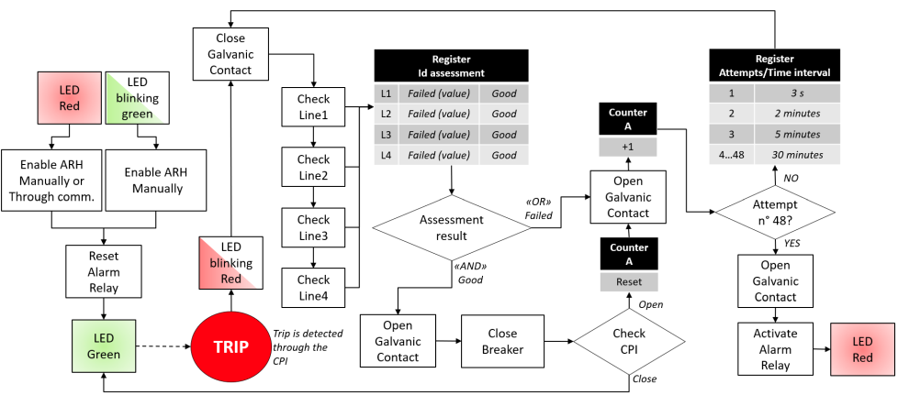

## ARH operations during a mains voltage drop (black-out)

|  |  |  |  |  |  |  |  |  |
| --- | --- | --- | --- | --- | --- | --- | --- | --- |
| MPD status | ARH status | ARH status definition | |  | | --- | | LED before the black-out | | What's happen during the drop off (ARH turns OFF) | What's happen at the mains restoring | |  | | --- | | LED  after the black-out | |
| Steady Closed (ON) | Active | The device is ready to work |  | MPD stays ON | It recovers its status: MPD closed and ARH activated |  |
| Steady Closed (ON) | No Active | The self-reclosing is not active |  | MPD stays ON | It recovers its status: MPD closed and ARH not active |  |
| Steady Open (OFF) | Active | It is not be possible: in order to activate the ARH, the MPD shall be Close (ON) | | | | |
| Steady Open (OFF) | No Active | The self-reclosing is not active |  | MPD stays OFF | It recovers its status: MPD open and ARH not active |  |
| Steady Open (OFF) | Dead time  (stand-by mode) | The time to wait among reclosure attempts |  | MPD stays OFF | Perform the assessment and, in case, reclose the MPD. The number of attempts is reset. |  |
| Steady Open (OFF) | Locked | The status when all the attempts are failed |  | MPD stays OFF | It recovers its status: MPD open and ARH locked. |  |
| Closing | Self-closing (after dead time) | The automatic reclosure of an MPD |  | The handle could stop in mid position | Open manoeuvre, then perform the assessment and, in case, reclose the MPD. The number of attempts is reset. |  |
| Opening | MPD tripping | The tripping of the MPD |  | MPD most probably goes in OFF | Open manoeuvre, then perform the assessment and, in case, reclose the MPD. The number of attempts is reset. |  |

NB: In case the status of the devices change (manually) during the black-out, ARH perform an internal check and set the correct steady status

## LED operations [2.1.8.1]

The indication shall be on the front of the device, visible from the operator and it consists in 2 colors (green and red) shown as in the following table:

|  |  |  |  |  |
| --- | --- | --- | --- | --- |
|  |  | **MOD** | **ARI/ARI-30** | **ARH** |
|  | OFF | Device not powered | Device not powered | Device not powered |
|  | Blinking Green | Device Powered but remote commands NOT activated | Device Powered but remote commands and automatic reclosing NOT activated | Device Powered but automatic reclosing NOT activated |
|  | Fix Green | Device Powered and remote commands activated | Device Powered, remote commands and automatic reclosing activated | Device Powered and automatic reclosing activated |
|  | Blinking Red | - | “Dead time” during the “standby mode” | “Dead time” during the “standby mode” |
|  | Fix Red | MPD has trip for a fault | Device in “Locked state” | Device in “Locked state” |

“*Standby mode*”: when the MPD trips and the device is waiting for an automatic operation

“*Dead time*”: waiting time between two assessments

“*Locked state*”: the device has completed its reclosing cycles and needs a reset to operate again

# Connectivity

The communication accessories shall be offered with wired (RS485) and wireless (WiFi) connectivity respectively.

It shall be possible to read status of the device remotely (main breaker open/closed, reclosing attempts…)

It shall be possible to execute basic commands remotely (open/close main breaker, write configuration)

The communication accessory shall connect to MOD using 4-pin side connector.

The power supply shall be provided from MOD. The communication to MOD shall be done with RS485.

## Wired Communication Accessory

The wired communication accessory shall connect to Insite Bus or generic RS485 MODBUS RTU bus.

The power supply lines from bus shall not be used, so the connection shall be done with 3 wires.

The accessory shall be addressed and configured according to Insite Bus or MODBUS RTU specification.

Modbus RTU specifications:

|  |  |  |
| --- | --- | --- |
| **Baud rate** | **Parity** | **Address** |
| 2400, 4800, 9600, 19200 (default), 38400, 57600, 115200 | Even (default), Odd, None | 1 - 247 |

The status of the device shall be indicated by 2-color LED (red/green).

The device shall be equipped with physical button (on front) to start or reset configuration.

The device shall be equipped with a dip-switch with 8 positions (on front) to set the modbus address.

It shall be possible to update the communication accessory firmware remotely.

It shall be possible to update the MOD firmware remotely, using communication accessory.

It shall be possible to update the ARH firmware remotely, using communication accessory.

## Wireless Communication Accessory

The wireless communication accessory shall connect the MOD to cloud or home automation services:

* Amazon Web Services (and Amazon Alexa)
* Microsoft Azure
* ABB free@home (plugin)
* Google home

The wireless communication accessory shall enable use of MODBUS TCP interface in local network.

Wireless module shall connect using 2.4Ghz 802.11b/g/n standard.

The status of the device shall be indicated by 2-color LED (red/geen).

The device shall be equipped with physical button (on front) to start configuration process or reset configuration to factory settings.

At first run or after factory reset the wireless accessory shall provide own wireless network with specific SSID and webserver available at fixed IP address to configure the device and make WiFi provisioning (connect to target network).

It shall be possible to update the communication accessory firmware remotely, using OTA (over the air) update function.

It shall be possible to update the MOD firmware remotely, using communication accessory and OTA update function.

It shall be possible to update the ARH firmware remotely, using communication accessory and OTA update function.

## Cloud connectivity and user interface

The wireless communication accessory shall be capable to connect to cloud applications, in order to get access to voice control services as Google Assistant and Amazon Alexa. This shall be done using “manufacturer cloud” which will on one hand directly access the voice services and mobile applications, and on other hand work as hub for all Wireless Communication Accessories.

The manufacturer (ABB) cloud will allow end users to register their devices and get access to remote control via Google, Amazon or other services. User shall be registered using their email address and own password.

Connection concept in case of Amazon and Google is presented in picture below.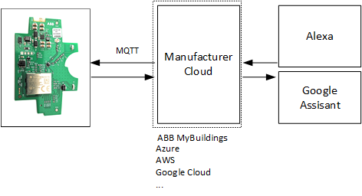

Connection to free@home shall be done in local network only, and the System Access Point from free@home system shall be used as gateway. The Communication Accessory shall communicate to System Access Point using Modbus TCP protocol. The system setup is presented in picutre below:

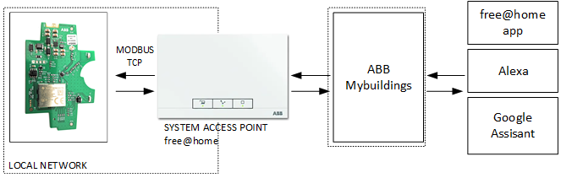

## Configuration of wireless communication accessory.

The configuration of wireless accessory shall be done using WiFi connection.

At first run or after factory reset the device shall be providing its own WiFi hotspor to which user shall connect. Then using specified local IP address (e.g. 192.168.0.1) in standard web browser user shall connect to configuration page.

The following functionalities shall be implemented on the configuration page:

* **Target WiFi settings**

User shall provide his own WiFi SSID and password. After applying the changes the device shall no longer work as hotspot - it shall connect to specified WiFi network. User shall be also capable of setting the standard LAN configurations such as IP address, gateway, etc.

* **Manufacturer cloud – username and password**

User shall provide his username and password that he got during registration at manufacturer cloud, in order to be able to control the device using voice services or mobile applications.

* **Device status and manual control**

User shall be able to test the functionality i.e. verify the status of the device and run a switching operation (t.b.d).

* **Firmware update**

User shall be able to see if there is a firmware update possible, both for all the product in range.

The user could trigger the update process when a new upgrade is available on ABB website o via mobile app.

The configuration webpage shall be also available after Wi-Fi provisioning, at IP address specified by end user. Anytime the device can be reset to factory settings using physical button on the device (e.g. reset executed if button is pressed for 10s).

## FW Upgrade

FW image shall be encrypted.

Modbus protocol shall be used for FW upgrade.

Frame:

|  |  |  |  |  |
| --- | --- | --- | --- | --- |
| **SLAVE ADDRESS**  **(ID)** | **FW UPGRADE**  **FUNCTION CODE** | **DATA** | **CRC H** | **CRC L** |
| **1 byte** | **1 byte** | **0 up to 252 byte(s)** | **1 byte** | **1 byte** |

0xFE = Modbus address of the COMM module on internal communication

0xFD = Modbus address of the MOD module on internal communication

0xFC = Modbus address of the ARH module on internal communication

FW Upgrade procedure for MOD/ARI/ARH is available only if they are in ‘NOT ACTIVE mode’ (device powered but commands/auto-reclosing not activated and led green blinking).

A communication register to set the ‘NOT ACTIVE mode’ shall be foreseen, to allow the FW upgrade procedure completely from remote.

In case the FW Upgrade shall be done on COMM module, does COMM module respond to the MOD on internal RS485 communication?

**Wi-Fi Communication**

**FW Upgrade for MOD**

1- Trigger for FW upgrade is sent by COMM module, via dedicated register.

2- MOD stop to send status/command telegram and send to the COMM a dedicated telegram to receive the first FW package.

3- MOD send requests, via FW upgrade telegram, to receive a new FW package until the COMM module respond with a “terminate telegram”

4- MOD calculate CRC and send to the COMM module the information about the result of the FW upgrade procedure: fail / success.

5- ‘Normal' internal communication can start again.

**FW Upgrade for ARH**

Same procedure as before but in this case, MOD works as a repeater for the ARH device.

**RS485 Communication**

Same procedure of the ‘Wi-Fi use case’.

In this case the FW Upgrade procedure is triggered by Master Modbus via Modbus telegram to the COMM module.

In this case there’ll be a delay because the third-party tool will be informed about the result of the FW Upgrade procedure only when effectively the FW upgrade has been done on the related devices (MOD/ARI/ARH).

When the FW has been received by the COMM module, it shall be checking the FW integrity and send the FW to the MOD/ARI/ARH only if the FW image is good.

At the end, when COMM module receive the information from MOD/ARI/ARH about the result of the FW Upgrade it can send this result to Master Modbus.

**Modbus Functions Upgrade**

**Upgrade Enable**

Request from the third-party tool

|  |  |  |  |  |  |
| --- | --- | --- | --- | --- | --- |
| **0** | **1** | **2** | **3** |  |  |
| **ID** | **0x41** | **0x01** | **Interface** | **CRC H** | **CRC L** |

Response from the COMM module

|  |  |  |  |  |  |
| --- | --- | --- | --- | --- | --- |
| **0** | **1** | **2** | **3** |  |  |
| **ID** | **0x41** | **RH** | **RL** | **CRC H** | **CRC L** |

Details

|  |  |
| --- | --- |
| **Interface** |  |
| Modbus RTU | 0x01 |
| Modbus TCP | 0x02 |

|  |  |
| --- | --- |
| **0xRHRL** |  |
| Success | 0x0000 |
| Fail | 0xFFFF |

**Upgrade Status**

Request from the third-party tool

|  |  |  |  |  |  |
| --- | --- | --- | --- | --- | --- |
| **0** | **1** | **2** | **3** |  |  |
| **ID** | **0x41** | **0x02** | **Interface** | **CRC H** | **CRC L** |

Response from the COMM module

|  |  |  |  |  |  |
| --- | --- | --- | --- | --- | --- |
| **0** | **1** | **2** | **3** |  |  |
| **ID** | **0x41** | **0x00** | **Status** | **CRC H** | **CRC L** |

Details

|  |  |
| --- | --- |
| **Status** |  |
| None | 0x00 |
| Success | 0x01 |
| Invalid FW | 0x02 |
| General Error | 0x03 |

# Product and system standard

Mandatory compliance to product standard IEC63024 ed1:2017, “Requirements for automatic reclosing devices (ARDs) for circuit-breakers, RCBOs and RCCBs for household and similar uses” [2.6.1]. This standard only refers to Automatic Reclosing Devices (ARI and ARH), so for the MOD it is used only as reference.

It is required a CB test report in accordance to the standard mentioned above [2.6.2] (only for ARH, not for MOD and ARI)

Compliance to 2014/30/EU - Electromagnetic Compatibility (EMC) Directive [2.6.3]

Compliance to RED for Wireless Communication Module [2.6.3.1]

Compliant to Directive 2011/65/EU - RoHs- on the restriction of the use of certain hazardous substances in electrical and electronic equipment [2.6.4]

Compliant to 2012/19/EU RAEE [2.6.5]

Compliant to the latest edition of REACH [2.6.6]

Codes featuring "Connectivity", shall be compliant with minimum cyber security requirements for products ABB directive 9ADB005793 [2.6.7]

# Packaging and labelling

## Package

Single product shall be packed in a single packaging solution (1pc/package) [3.1.1]

Layout shall comply with ABB design guidelines [3.1.2]; LVD contents must be included [3.1.3]

Packaging shall be used as marketing material at first presentation of the device [3.1.4]

## Label (on the package)

For every package, the label layout shall comply with ABB design guidelines [3.2.1]

LVD and WEEE contents must be included (address of manufacturer) [3.2.2]

Languages of label are IT, EN, DE, FR, ES [3.2.3]

## Marking (on the product)

General content [3.3.1]

The marking shall be compliant with the information required by product standards [3.3.1.1] and with the ABB design guidelines [3.3.1.2]

There shall be present also all the requirements from the LVD and WEEE directive content [3.3.2]

* Manufacturer address [3.3.2.1]
* Safety symbol [3.3.2.2]
* Tightening torque [3.3.2.3]
* Stripping length of cable [3.3.2.4]
* Garbage bin [3.3.2.5]

## Instructions leaflet

All the instructions (complete manual) shall be printed on its own leaflet as a quick guide: MOD, ARI, ARH and the Communication modules instructions must be included in this leaflet.

All the instructions shall be in 5 languages (IT, EN, DE, FR, ES)

User documentation

Installation manual MOD, ARI,

Installation manual ARH

Installation manual COM – MOD

Installation manual COM – Wi-Fi

# Marks and approvals

All the products in the range shall have the following marks:

* CB test and test reports in accordance to standard IEC63024 ed1:2017 (only ~~for ARI~~ ***[DEVIATION]*** ARH) [2.6.1]
* CE [4.1.1]
* Made in… (There are not restrictions for manufacturing country [4.2])
* RoHS [4.3.2]
* Reach [4.3.3]
* WEEE [4.3.4]

# Documentation

The following documentation shall be available for the customer at the end of the project:

* Operating and installation instructions [5.1.1]
* Data for software tools [5.1.2]
* Datasheet [5.1.3]
* Tables and charts [5.2]
* 2D drawing [5.3.1]
* 3D drawing [5.3.1]

# Revision History

|  |  |  |  |
| --- | --- | --- | --- |
| **Rev.** | **Description** | **Date** | **Owner** |
| 00 | First release | 28-Apr-21 | ITABB/R&D/P.Antonello |
| 01 | Modification par. 3.4 *- ARH connection* | 23-Sep-21 | ITABB/R&D/P.Antonello |
| 02 | Modification par. 5 – Operating Voltage | 27-May-22 | ITABB/R&D/P.Antonello |
| 03 | Modification par. 7 – Operations | 3-Oct-22 | ITABB/R&D/P.Antonello |
| 04 |  |  |  |
| 05 | Modification par. 4.2Modification par. 6 – EnvironmentalModification par. 11 – Mark and approval | 4-Apr-23 | F. Rigamonti/F. Passone |
| 06 | Modification of Make and opening times, voltage range, endurance, Power consumption, accessories | 12-Apr-23 | F. Rigamonti/F. Passone |
| 07 | Modification of led behavior in 7.2.2 | 03-May-23 | C.Borriello |
| 08 | Refining of accessoriability with diagrams 3.5 Update of 4.2 with S204P compatibility and operation requirements without accessories  Update of chapter 9, CB report only for ARH  Update of SIG and AUX behavior chapter 3.3 | 5-May-23 | F. Rigamonti/F. Passone |